Number of Chaperones | 2 | 10
Number of Students | 8 |  | 160
- On a field trip, 2 chaperones are needed for every 8 students. How many chaperones are needed for a trip with 160 students? Use the ratio table given to solve the problem.

Cups of Flour | 5
Number of Cookies | 75 |  | 30
- A baker uses 5 cups of flour to make 75 cookies. Using this same ratio, how many cups of flour will be needed for 30 cookies? Use the ratio table given to solve the problem.

- Stephen has 32 baseball cards and 18 football cards. What is the ratio of baseball cards to football cards? Write as a fraction in simplest form.

- There are 15 boys and 12 girls in class. Write the ratio of girls to boys in simplest form. What does the ratio mean?

Write each rate as an unit rate.
- 4 notebooks for $2.50
 | $0.63 per notebook |  | $1.60 per notebook
 | $10 per notebook |  | $2.50 per notebook

- 3 championships in 7 years
 | 3 championships per year |  | 0.43 championships per year
 | 0.86 championships per 2 years |  | 7 championships per year

- 300 words in 4 minutes
 | 134 words per minute |  | 70 words per minute
 | 75 words per minute |  | 80 words per minute

Math Problems Completed
Number of Hours, x | Number of Problems, y
1 | 2
2 | 4
3 | 6
 | ​  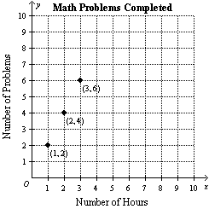  ​ |  | ​  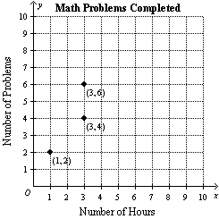
 | ​  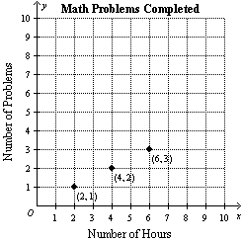  ​ |  | ​  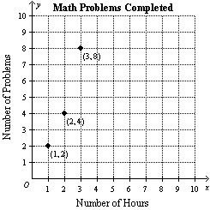  ​
- The ratio table below shows the number of math problems a student completed each hour. Choose the correct graph of the ratio table.
9. In the 2008 Olympics, Samuel Kamau Wanjiru ran a marathon in 2.11 hours. A marathon is 26.2 miles, about how many miles per hour was Samuel running? Round to the nearest tenth.

- A 6-pack of canned soda is on sale for $1.69. The same brand of soda is also available in an 8-pack for $2.59.
​
a. Find the unit rate for each pack of soda.
​
b. Which is less expensive per can: the 6-pack or the 8-pack?
​
c. Explain the difference between a ratio and a unit rate, and cite an example of each.

Number of Miles | 4.5 |  |  |  | ?
Time (min) | 15 |  |  |  | 75
- Tommy can ride his bicycle 4.5 miles in 15 minutes. How many miles can he ride in 75 minutes?

 | 9 |  | 13.5
 | 22.5 |  | 27
- Mrs. Damiani can run 8.6 miles per hour. How many miles can she run in 0.5 hour?

- There are 42 students in the Inman Middle School orchestra. The ratio of girls to boys is 2:5. How many girls are in the band?

- Two Six Flags tickets cost $84.50. How much will it cost for 5 Six Flag tickets?

- What number is 15% of 200?
 | 3 |  | 7.5
 | 15 |  | 30
​

- 83% of 196
 | 125 |  | 80
 | 160 |  | 100
​

- 45 is 15% of what number?
 | 3 |  | 15
 | 200 |  | 300
​

- 19 is 38% of what number?
 | 2 |  | 38
 | 50 |  | 200
​

- At a cookware party, 7 of the 25 items are made of glass. What percent of the cookware items are glass?

Write the percent as a fraction in simplest form.
- 45% 21. 125%

Write the fraction or mixed number as a percent.
- 5/8 23. 2 3/5

- 5 gal = ____ qt
1.25
10
40
20
​

- 196 oz = ____ lb

- If 1 cm = 0.39 in., then 52 in. = _____________cm

- If1 kilogram equals to 2.20 pounds., then 8.80 pounds = _____________kg.

- The table shows the amount of time Phil trains each week for triathlons. What is the ratio of time spent running to total time training? Write as a fraction in simplest form.
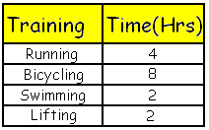

- FRUITS Find the ratio of bananas to oranges in the graphic below. Write the ratio as a fraction in simplest form. Then explain its meaning.
 | This means for every 1 banana, there are 3 oranges |  | This means for every 1 banana, there are 4 oranges
 | This means for every 1 banana, there are 5 oranges |  | This means for every 2 bananas, there are 5 oranges
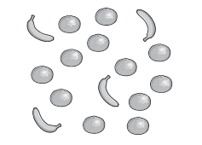

In Problems 30-32, use the table that shows the number of hits made in the game.
TEAM | BRAVES
Number of singles at bat | 16
Number of doubles at bat | 8
Number of triples at bat | 6
Home Runs | 2

- What percent of the total base hits were singles?__________________
- What percent of the total base hits were doubles?________________+_
- What percent of the game hits were Home Runs?__________________

